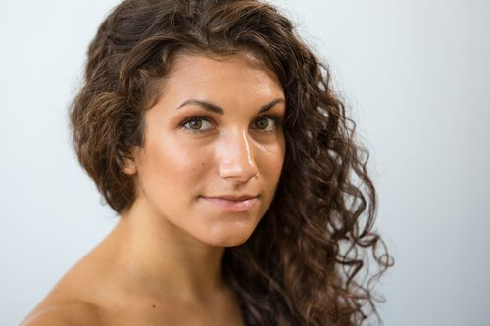
MARY KATE SHEEHAN
is a modern and contemporary dance artist working in both New York City and Europe. She is from San Diego, CA, where she trained in ballet, jazz, modern, contemporary, pointe, theater, and hip hop at the Academy of Performing Arts under the direction of Kevin Patterson.
Mary Kate performs with a number of acclaimed companies including Yvonne Rainer, KEIGWIN + COMPANY, and Seán Curran Company. She participates in many dance events around the world for other choreographers and companies, including Julia Ehrstrand/Ehrstrand Dance Collective, Tyler Gilstrap/tunanut productions, Marlena Wolfe/the wolfe project, Darrah Carr Dance, Shelly Hutchinson/Hutchinson Collaborative, and The Windmill Factory. Mary Kate is the General Manager of Sidra Bell Dance New York.
Mary Kate is an accomplished teacher in the New York City area as well as internationally. She is modern and contemporary faculty at both STEPS on Broadway and Peridance Capezio Center. She has directed dance programs/curricula in Sweden, and she has taught and set choreography in Sweden, the UK, Germany, the Netherlands, Greece, Taiwan, and South Africa in professional, pre-professional, and outreach settings.
She is also a highly-acclaimed champion Irish step dancer, trained by Liam Harney and Michelle Malone-Chiles. Mary Kate appeared as a semi-finalist on Season 8 of So You Think You Can Dance as an Irish dancer. She is a graduate of the Joffrey Ballet School Pre-Professional Trainee Program and holds a B. A. in Performing Arts with an Emphasis in Dance from St. Mary's College of California. Her professional training includes Hofesh Shechter, David Parsons, Ohad Naharin/Gaga, Shannon Gillen, and more.

http://www.mksheehan.com/

